I. DESCRIPTION OF POSITION
MISSION: The Canadian Federation of Medical Students is the national voice of Canadian Medical Students.
We connect, support and represent our membership as they learn to serve patients and society.
VISION: Tomorrow’s physicians leading for health today.

GUIDING PRINCIPLES:
• member-driven organization relevant to all medical students from admission through to transition to residency
• prioritizes institutional transparency through ongoing and active engagement of medical student societies and their constituent students
• celebrates diversity of all forms including race, national or ethnic origin, mental or physical disability, age, religion, sexual orientation and gender identity, and in turn, promotes the establishment of safe spaces for all
• recognizes the varied cultural, social and economic context within which medical students live

I. EXECUTIVE SUMMARY AND RESPONSIBILITIES
Connecting: Both regional representatives are in charge of maintaining communication between their region’s schools and the executive. In the case of Ontario schools, they liaise with the Ontario Medical Students’ Conference (OMSA) and the six schools in Ontario (Western University, University of Toronto, McMaster University, Northern Ontario School of Medicine, and University of Ottawa). They give updates to the executive as well as maintain dialogue between all these schools. This year, Shreya also had the privilege of chairing the Presidents’ Roundtable.
Representing: Kaylynn represented the CFMS on several AFMC Electives Portal Committees including: Immunizations, Steering and Enhancements, as well as the CaRMS Review Committee, and the Entry Routes Working Group. Shreya represented the CFMS to the Royal College Committee on Specialty Education and the AFMC Electives Portal Data Analysis Working Group, and at conferences such as the FMEQ Lobby Day, Canadian Health Coalition Conference on a national pharmacare strategy.
Supporting: Kaylynn and Shreya supported the Communications Committee during the interim period leading upto the election of a replacement VP Communications at SGM 2017. Both Kaylynn and Shreya supported the VP Education portfolio and Nominations Committee.

II. MEETINGS ATTENDED
Date | Meeting | Location | Attended By
September 22-25th, 2016 | CFMS Annual General Meeting | Edmonton, AB | Both
October 15th, 2016 | CFMS Fall Executive Meeting | Teleconference | Both
October 16th, 2016 | Ontario Medical Students’ Weekend | London, ON | Tavis Apramian
October 17th, 2016 | CaRMS Review Committee | Ottawa, ON | Kaylynn Purdy
October 17th, 2016 | CFMS Representatives Roundtable | Teleconference | Shreya Jalali
October 18th, 2016 | Ottawa Med Soc Meeting | Ottawa, ON | Shreya Jalali
October 24th, 2016 | AFMC Immunization Working Group | Teleconference | Kaylynn Purdy
October 28th, 2016 | CFMS President 1-on-1 Exec Meetings | Teleconference | Both
November 4-6th, 2016 | CFMS Fall Executive Meeting | Ottawa, ON | Both
November 13th, 2016 | CFMS Academic Roundtable (Chair) | Teleconference | Shreya Jalali
November 16th, 2016 | AFMC Portal Data Analysis WG | Teleconference | Shreya Jalali
November 17th, 2016 | UofT Med Soc Meeting as CFMS Exec. | Teleconference | Shreya Jalali
November 24th, 2016 | Royal College Committee on Specialty Ed. | Ottawa, ON | Shreya Jalali
November 25-27th, 2016 | OMA General Council Meeting | Toronto, ON | Shreya Jalali
December 3rd, 2016 | OMSA Council Meeting | Toronto, ON | Both
December 19th, 2016 | CFMS Presidents’ Roundtable | Teleconference | Shreya Jalali
January 7th, 2017 | OMSA Council Meeting | Toronto, ON | Shreya Jalali
January 7th – 8th, 2017 | CFMS Winter Executive Meeting | Toronto, ON | Both
January 10th, 2017 | uOttawa Med Soc Meeting | Ottawa, ON | Shreya Jalali
January 11th, 2017 | AFMC Electives Groups | Teleconference | Kaylynn Purdy
January 12th, 2017 | AFMC Electives Portal Steering | Teleconference | Kaylynn Purdy
January 16th, 2017 | AFMC Steering Committee | Teleconfernce | Kaylynn Purdy
January 18th, 2017 | CaRMS Application Review Executive | Teleconference | Kaylynn Purdy
January 24th, 2017 | OMSA Teleconference pre-SCM | Teleconference | Shreya Jalali
January 26th, 2017 | AFMC Enhancements Working Group | Teleconference | Kaylynn Purdy
January 29th, 2017 | CFMS Presidents’ Roundtable | Teleconference | Shreya Jalali
January 31st, 2017 | CFMS Representatives’ Roundtable | Teleconference | Shreya Jalali
February 2nd, 2017 | AFMC Immunization Working Group | Teleconference | Kaylynn Purdy
February 14th, 2017 | AFMC Portal Data Analysis WG | Teleconference | Shreya Jalali
February 25th, 2017 | CFMS Executive Meeting | Teleconference | Both
February 28th, 2017 | CFMS Presidents’ Roundtable | Teleconference | Shreya Jalali
March 4th, 2017 | OMSA Council Meeting | Sudbury, ON | Shreya Jalali
March 8th, 2017 | CFMS Representatives’ Roundtable | Teleconference | Shreya Jalali
March 10th, 2017 | AGM Planning Meeting | Ottawa, ON | Shreya Jalali
March 14th, 2017 | AFMC Portal Steering Committee | Teleconference | Kaylynn Purdy
March 24-27th, 2017 | OMSA Wellness Retreat | Georgina, ON | Shreya Jalali
March 28th, 2017 | CFMS Presidents’ Roundtable | Teleconference | Both
April 2nd, 2017 | OMSA Council Meeting | Teleconference | Both
April 3rd, 2017 | Strategic Operations Plan 1:1 Meeting | Teleconference | Both
April 3-4th, 2017 | FMEQ Lobby Day | Quebec City, QC | Shreya Jalali
April 10-11th, 2017 | Canadian Health Coalition Conference | Ottawa, ON | Shreya Jalali
April 19th, 2017 | CFMS Executive Meeting | Teleconference | Shreya Jalali
April 21st, 2017 | AGM Sponsorship Meeting with uOttawa | Ottawa, ON | Shreya Jalali
April 27th – 30th, 2017 | CFMS Spring General Meeting | Winnipeg, MB | Both
April 29th, 2017 | Electives Network | Winnipeg, MB | Kaylynn Purdy
April 30th, 2017 | AFMC Portal Immunizations WG | Winnipeg, MB | Kaylynn Purdy
May 1st, 2017 | MCC Lunch | Winnipeg, MB | Both
May 1st, 2017 | AFMC Data Analysis Workshop | Winnipeg, MB | Both, Shreya presented
May 1st, 2017 | AFMC Portal Steering Committee | Winnipeg, MB | Kaylynn Purdy
June 27th, 2017 | AFMC Portal Steering Committee | Teleconference | Kaylynn Purdy
June 28th, 2017 | Entry Routes Working Group | Teleconference | Kaylynn Purdy
July 7-9th, 2017 | CFMS Summer Executive Meeting | Calgary, AB | Both
August 21st, 2017 | AFMC Portal Steering Committee | Teleconference | Kaylynn Purdy
Sept. 1st, 2017 | Entry Routes Working Group RDoC Rep | Teleconference | Kaylynn Purdy
Sept. 13th, 2017 | AFMC Portal Data Analysis WG Meeting | Teleconference | Shreya Jalali
Sept. 19th, 2017 | CFMS Executive Meeting | Teleconference | Both

III. PRIORITIES AND PROJECT AREAS
Ontario Representation
- The primary role of regional representation is accomplished through interaction with OMSA. Shreya has participated in all but one OMSA Executive Meeting and multiple OMA meetings this year as a cross-appointed VP External and thus fully funded OMSA Council member. She was also able to attend OMA Kaylynn has also been able to attend several OMSA meetings via teleconference.
- A written update from the CMFS was provided at each meeting starting in January 2017, and will continue to be done henceforth. This update is well-received and allows important collaboration between these two organizations on common issues and ongoing projects. Similarly, updates from the OMSA Executive meetings and OMA meetings were presented at CFMS Executive meetings.
- This is a crucial relationship and we encourage all future Ontario Regional Representatives to maintain open communication between these two organizations.

ii. Presidents’ Roundtable
- Shreya chaired the monthly Presidents’ Roundtable starting shortly after AGM 2016. It has been a vibrant and well-attended forum for presidents from across Canadian medical schools to share local information and work through common concerns together.
- This year, we impemented a live combined agenda and working document as well as a Doodle scheduling system to ensure ease of accessibility and user-friendly interfaces for our teleconferences.

iii. AFMC Portal Working Groups – Immunizations, Steering Committee and Enhancements
- Kaylynn collected first-hand accounts of CMFS members about their portal experience and presented to the Electives Network at CCME a collection of student concerns. Very well received by the Elective’s Network, and they committed to working to resolve student concerns.
- Immunization meeting- pushed for a supplemental immunization form for students so that they do not need to repeat the entire common form.
- Steering committee has received student concerns and has made them a top priority including the 8 Week rule, verification timelines, fees ect. (See infographic made by VP Comms).
- Kaylynn advocated for more frequent student application updates on the portal which came into effect in July, 2017.
- Through a presentation to the Electives Network a CCME Kaylynn was able to get NOSM improve their elective policies, improve the verification process at many schools, and have the electives network form a working group to establish a fee and refund model for all schools.

- AFMC Portal Data Analysis Working Group
- Shreya represented us to this working group, whose purpose is to recommend business intelligence specifications, performance measures, and data collection need to support policy decisions over time.
- The AFMC Student Portal Data on Visiting Electives for 2015-2016 was released in February 2017. Aggregate level data was shared in a national report and school-specific reports were created for each of the 17 faculties of medicine. Shreya and the other working group members helped provide input for the data collection template to help illustrate visiting elective activity across Canada and inform policy.

- CaRMS Application Review Commiteee
- Kaylynn advocated for students on the most pressing improvements that need to be made to the online CaRMS application. The overall goal here is to best capture the profile of a student and provide a better interface for students to use during this process. Will be meeting again over the summer.
- Kaylynn attended an in person meeting in October 2016 to improve the application for the 2018 match and will be attending another meeting in November 2017 to improve the application for the 2019 match.

- Strategic Initiatives Fund Committee
- Shreya serves as one of the inaugural executive members on this newly formed and growing committee, which also includes two presidents from different Canadian medical schools, and will evaluate applications for grants that fund initiatives that further the CFMS’ strategic vision

- Entry Routes Working Group
- Kaylynn attended a teleconference with RDoc, AFMC, RCPS, and CCFP to discuss entry routes. Will be attending further teleconferences over the summer and an in-person meeting in the fall. Current objective is to define the problem of entry routes in Canada, focus of Kaylynn and CFMS is the pressure placed on students to narrow themselves early on and the stress of the match.
- Kaylynn created a survey to for both Canadian medical graduates and international medical graduates to determine Canadian medical student views on our current entry to residency process and the views of the process in different countries.
- Will be attending an in person meeting on Nov. 23, 2017 in Ottawa

- Med Soc Meetings Pilot Project
- Kaylynn and Shreya are in the process of piloting a new initiative this year to reach out to all the Ontario medical schools’ students, by attending the medical student society meetings in person or by teleconference if required.
- The goal is to increase transparency and local outreach, by personally being available to better connect with members, answer questions, and understand student needs at each school. This will allow us to better use student input to guide and shape the direction of CFMS projects.

- 40th AGM Planning & Chairing
- Shreya worked closely with Rosemary Conliffe, our office manager based in Ottawa, as well as a team of exec members, supporting national officers, and local uOttawa students to help plan the CFMS’ 40th Annual General Meeting and special 40th anniversary day, being held in Ottawa this year
- This project has required multitasking across various portfolios and liasing with many of our major stakeholder organizations and reaching out to new ones, e.g. national specialty organizations and new guests such as MINC

IV. FOLLOW UP, VISION, GOALS & RECOMMENDATIONS FOR THIS POSITION
Follow Up:
- The President’s Round Table Will need to be continued and run by a new board member
- Representation on the 4 Portal AFMC Committees will need to be transitioned to a new Board and member rep.
- OMSW Board representation by will need to decided (responsibility of Ontario Rep)

Vision:
Our vision as Ontario Regional Representatives was to unite the 6 Ontario medicals schools by providing a strong individual voice for each school and a collective provincial voice.

Recommendations:
Ontario Regional Representative is a role that you can shape how you see fit to best see the membership. Shreya and Kaylynn took on a strong voice for medical education issues affecting not only Ontario students, but all Canadian medical students.

V. REFLECTIONS & CONCLUSIONS
We would like to thank the membership for electing us to the CFMS board as your Ontario Regional Representatives for the 2016/2017 year. It was an honour and a pleasure to serve the membership over the past year. We were passionate about making a difference in the lives of medical students, about making the experience as a medical student better, and about building a brighter future in medical education. We hope that we have left the CFMS and medical education in Canada a better place than when we started.
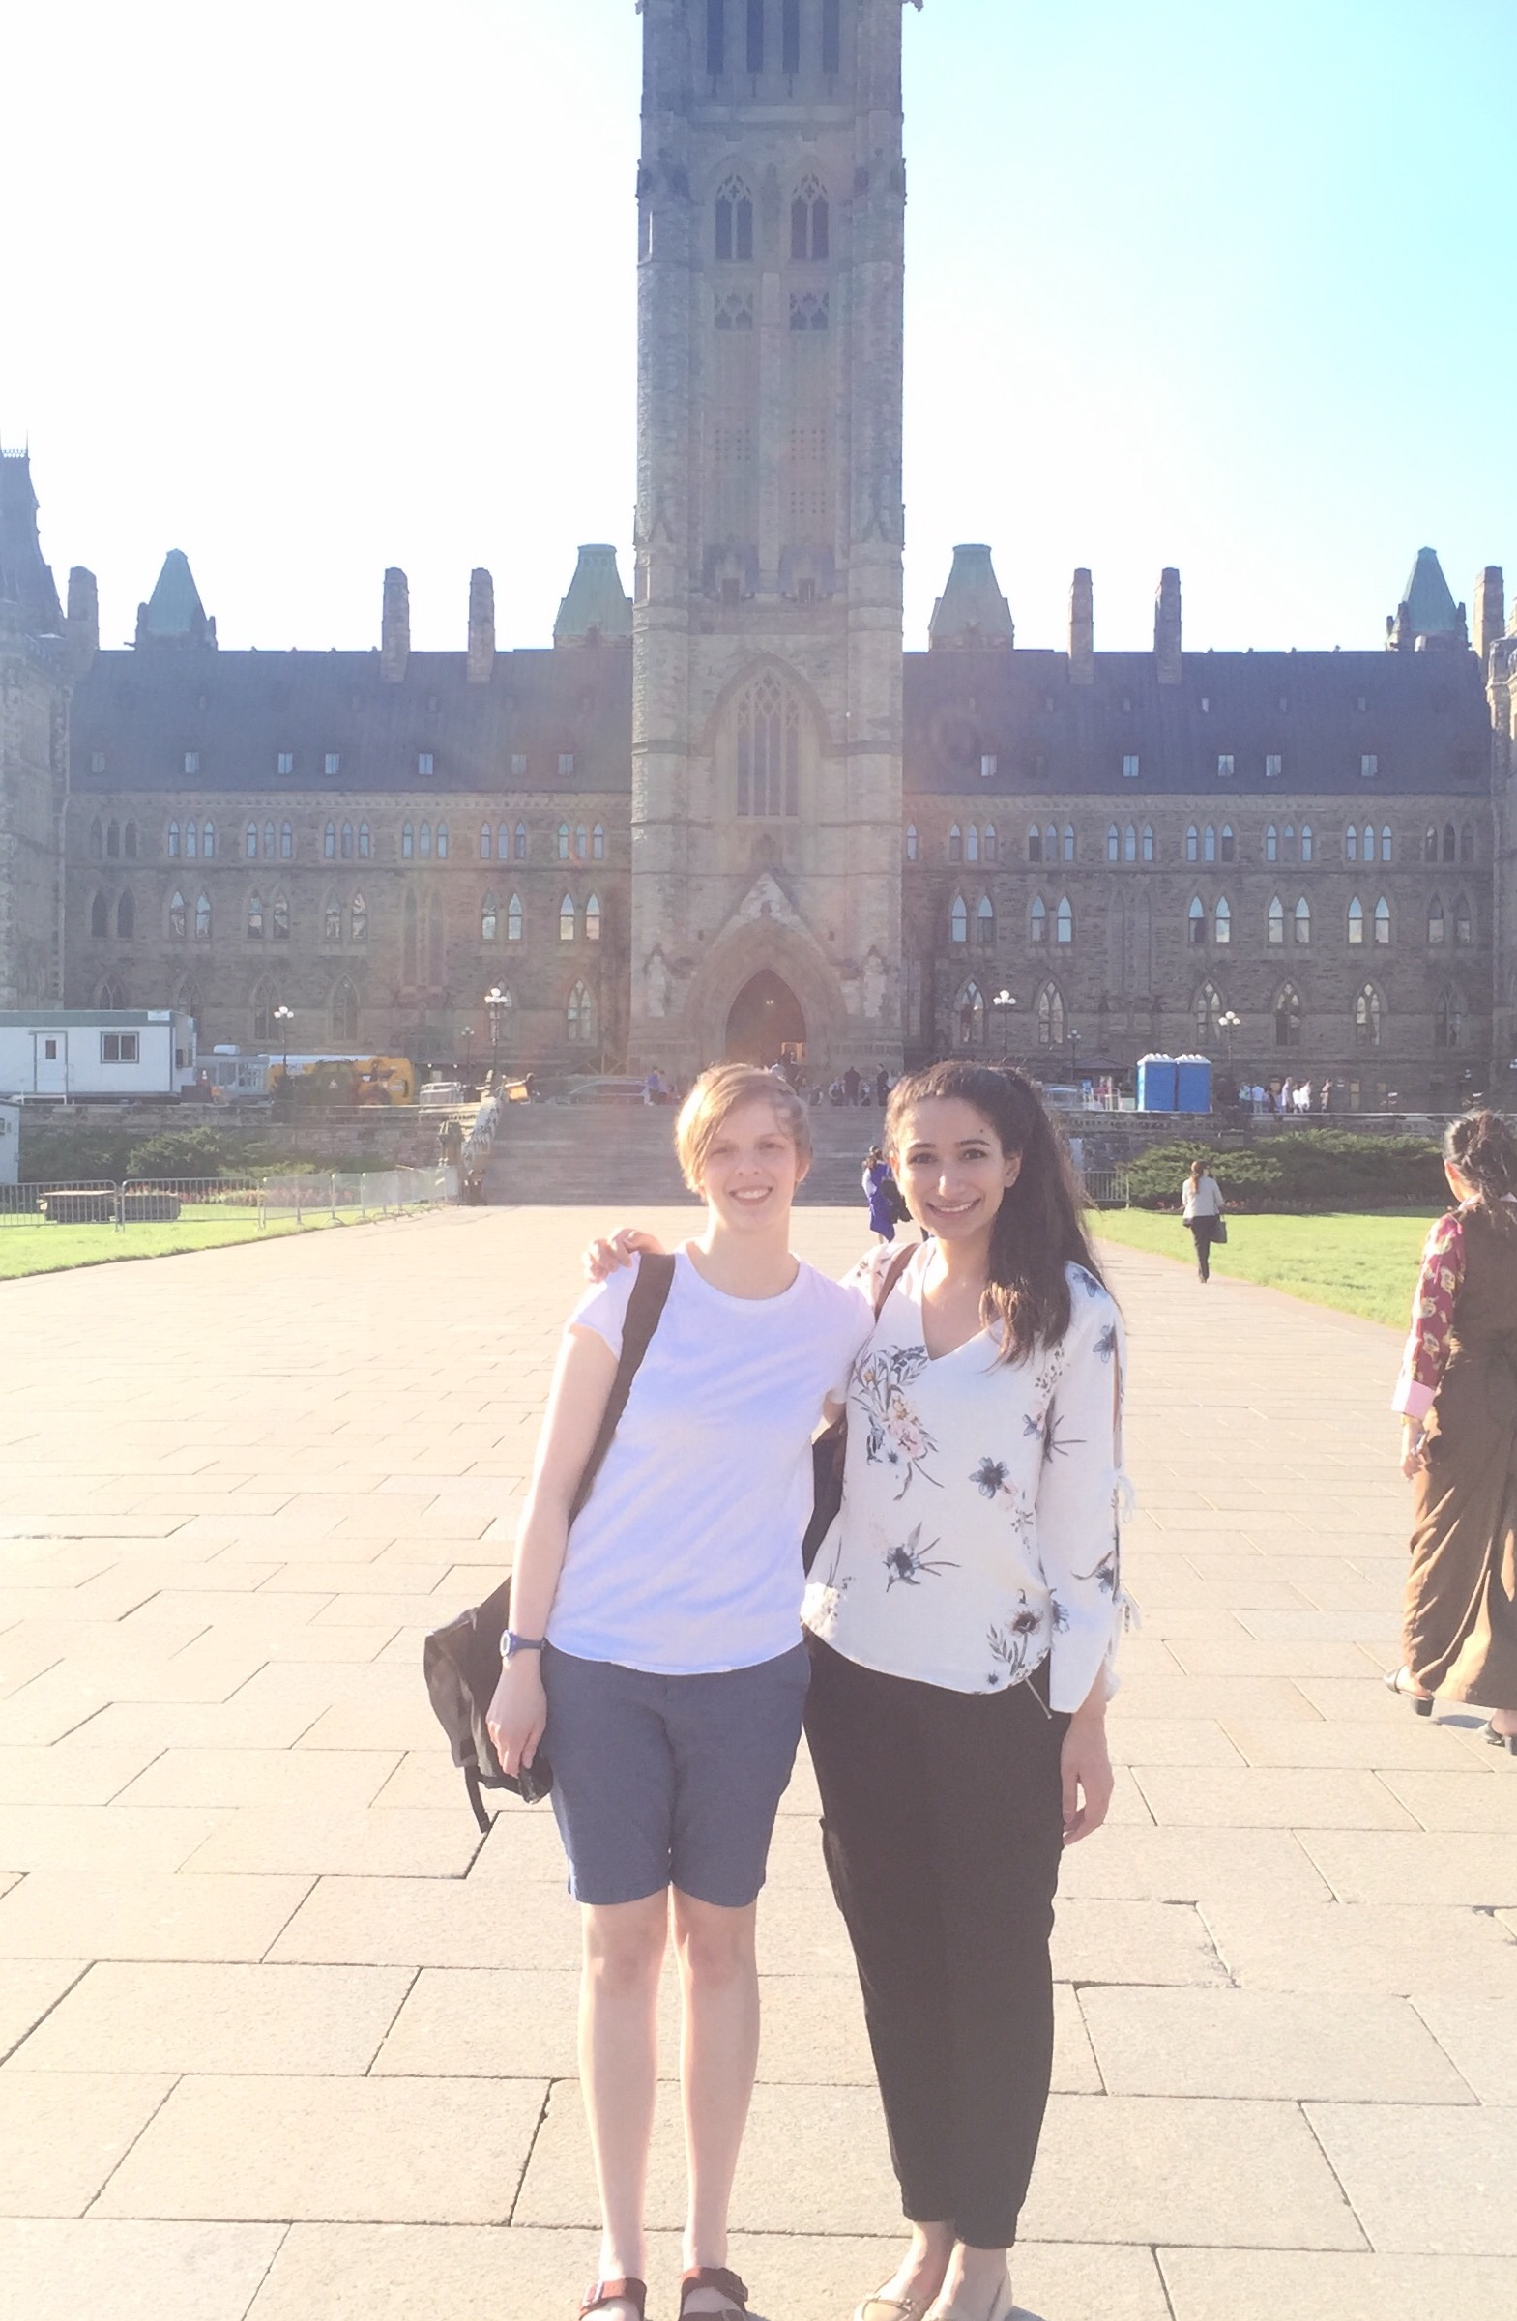
Please do not hesitate to contact us at kpurdy@nosm.ca or sjala037@uottawa.ca if you have any questions following this report.

“This is not a goodbye, my darling, this is a thank you.”
~ Nicholas Sparks
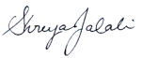
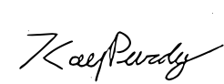
Kaylynn Purdy & Shreya Jalali
CFMS Ontario Regional Representatives 2016-2017

